Consolidated Field visit report

**1**

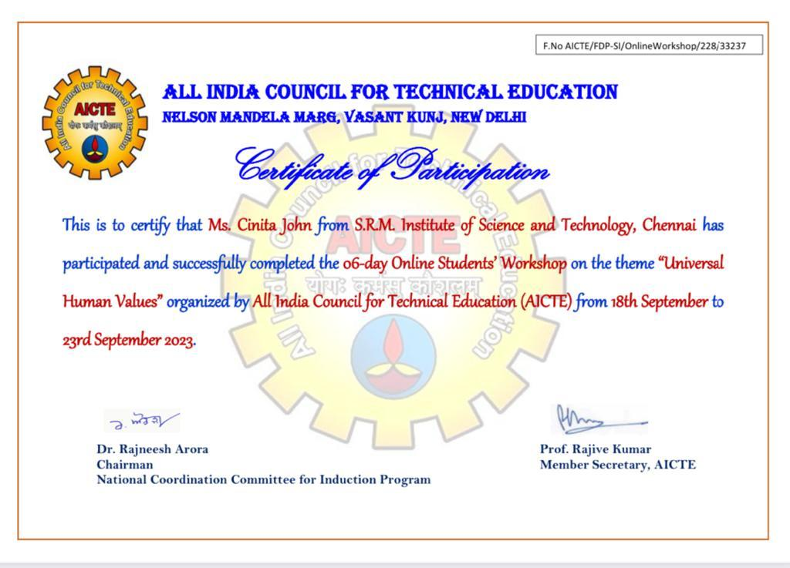

IMPACT:

Attending a workshop is a deeply personal journey for me. It provides a unique opportunity for self-reflection and growth. The impact is profound, as it not only enhances my self-awareness but also helps me discover my strengths and weaknesses. This self-discovery, in turn, leads to improved confidence and a greater sense of purpose.

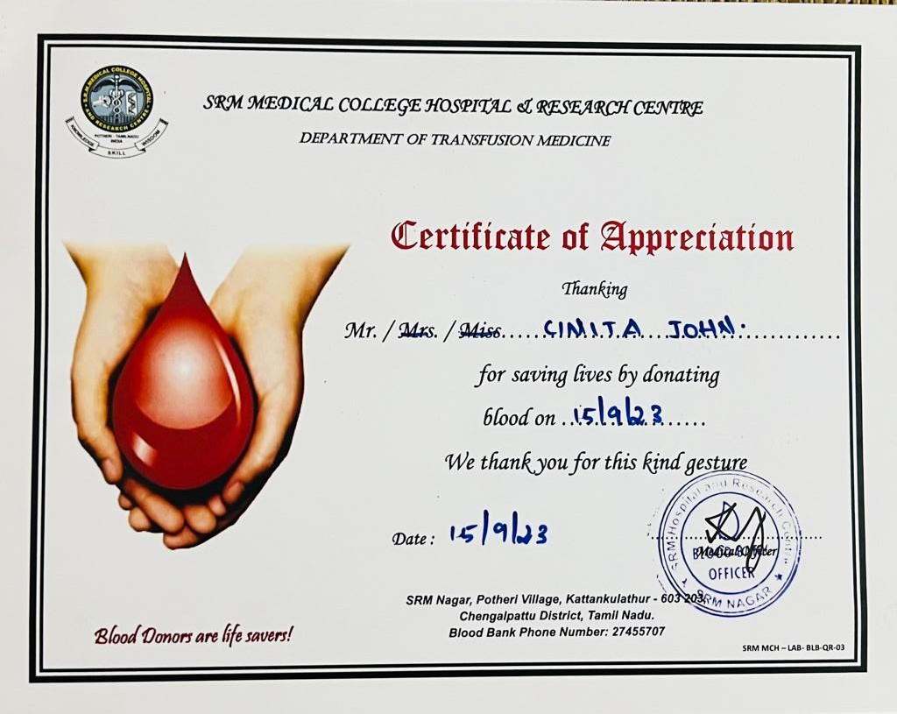

IMPACT:

Donating blood is not just about helping others; it's a personal journey with meaningful self-impacts. The satisfaction and fulfillment I feel knowing I can save lives are incredibly rewarding. . It's also a way for me to actively engage with my community, strengthen social bonds, and be a part of something bigger.

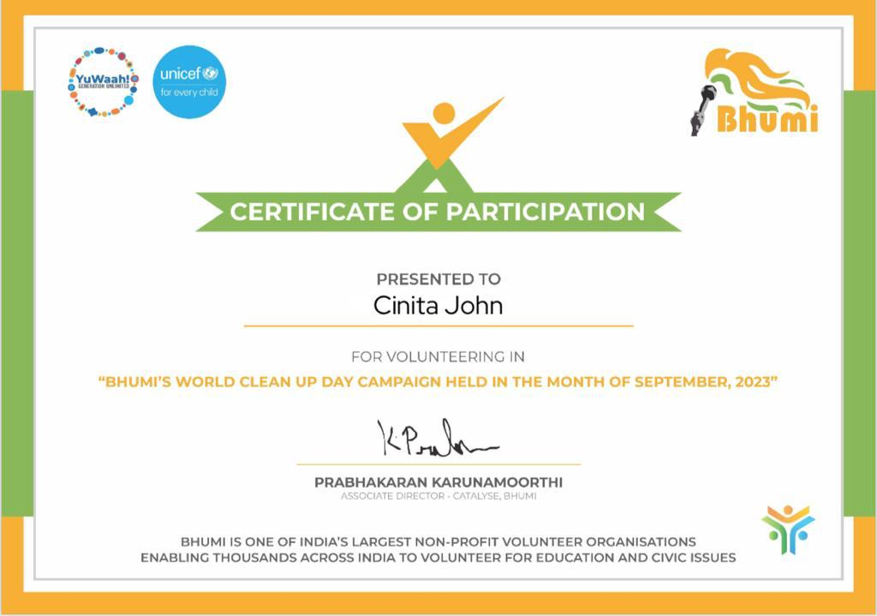

IMPACT:

Cleaning the beach has made a big impact on me. When I pick up trash and plastic on the shore, I feel like I'm doing something important for the environment. Seeing the beach go from dirty to clean is really satisfying. It reminds me that even small actions can help save the Earth, and it inspires me to keep working to protect our beautiful coastal areas for the future.

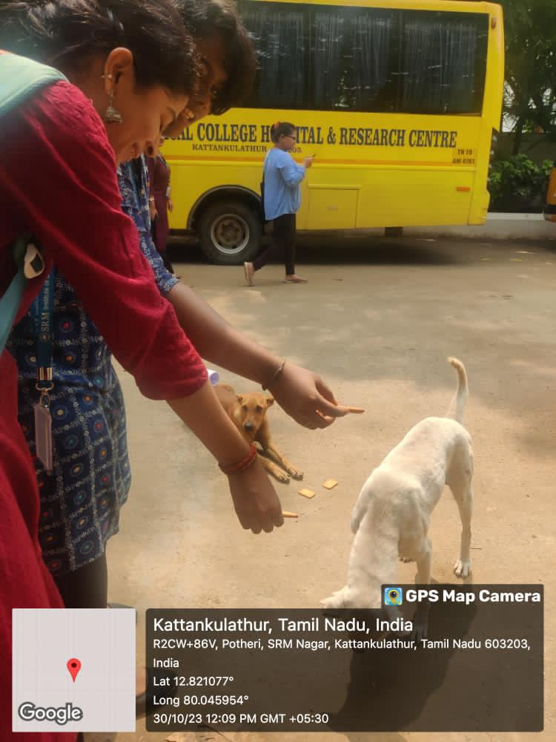

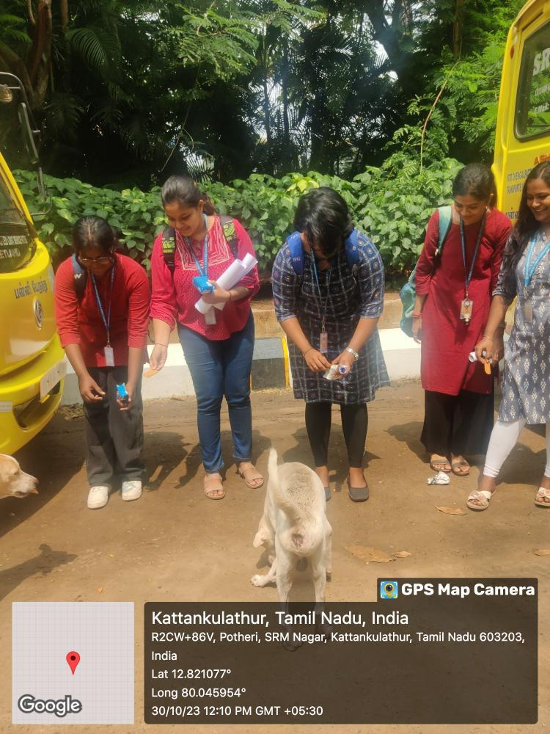IMPACT:

Feeding my dogs has been a daily ritual that brings me immense joy and a sense of responsibility. The sound of their eager barks as I prepare their meals, the wagging tails and grateful eyes that follow as they devour the food I've chosen for them – it's a simple yet profound connection. Not only does it ensure their physical well-being, but it strengthens our bond, reminding me that in their world, It's a small act that carries significant emotional weight, reaffirming the unique and cherished relationship I have with my furry companions

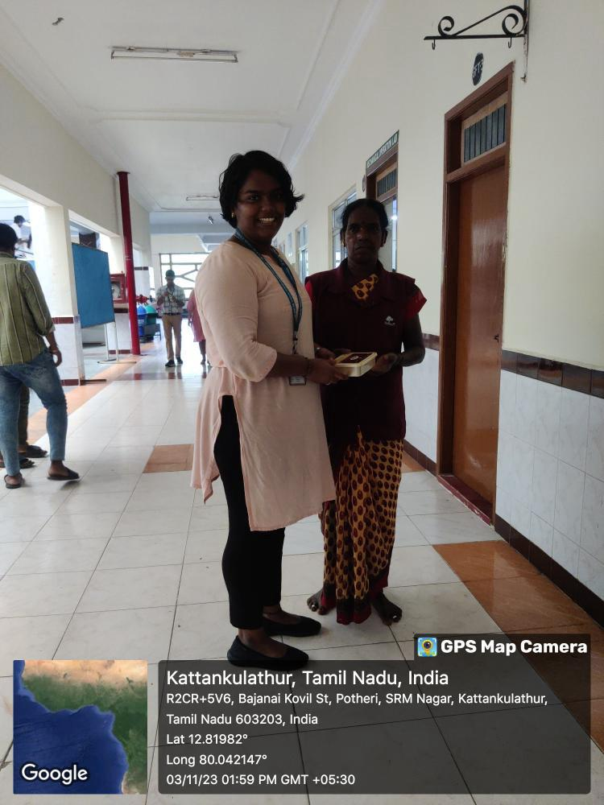

IMPACT:

Giving sweets to supporting staff as a token of gratitude has a profound self-impact for me. It's not just about expressing appreciation but also a way to strengthen the bonds that we share. The act of giving sweets becomes a reflection of my gratitude, and it warms my heart to see their smiles.

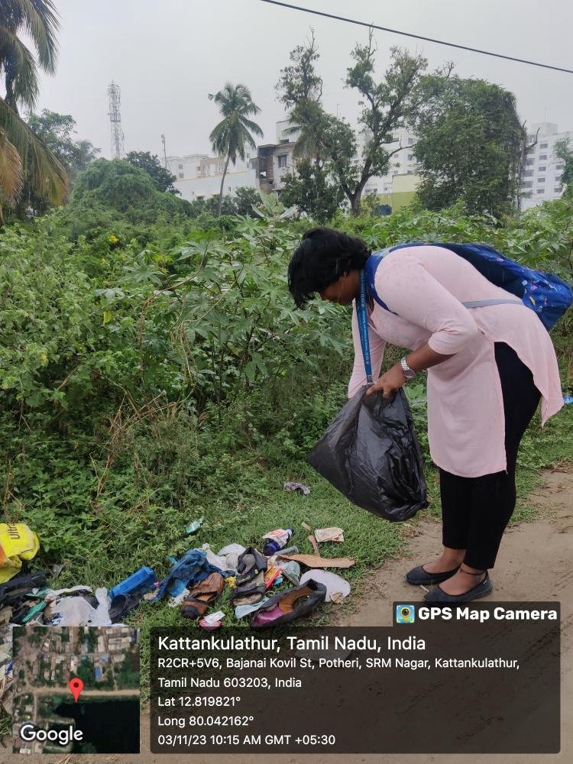

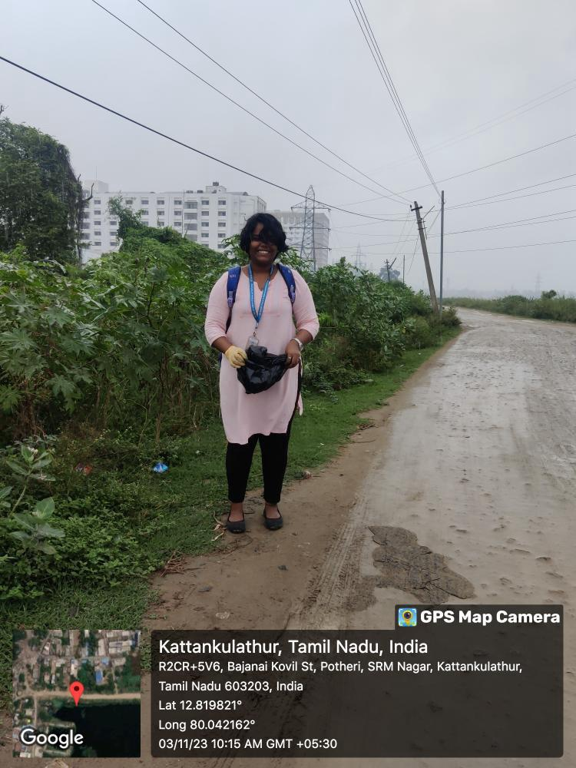

IMPACT:

Cleaning my surroundings has a big impact on me. It makes me feel more organized and in control of my life. When I tidy up, I can think more clearly, and it reduces stress. Plus, it's nice to come home to a clean and comfortable space. So, cleaning isn't just about a neat room; it's about how it makes me feel better and more at ease in my own space